# COMPUTER SCIENCE & ENGINEERING



**CHANDIGARH UNIVERSITY**

**UNIVERSITY INSTITUTE OF ENGINEERING**

**DEPARTMENT OF COMPUTER SCIENCE AND ENGINEERING**



|  |  |
| --- | --- |
| **Submitted by:**  **Yash Gupta 20BCS5009** | **Submitted To:**  Ajay Kumar (E13141) |
| **Subject Name:** | Machine Learning Lab |
| **Subject Code:** | 20CSP-317 |
| **Branch:** | CSE |
| **Semester:** | 5th |

**Aim:** Implementation of k-mean clustering values on any data set.

**Objective:** To prepare a model with k-mean clustering values on any data set.

**Data Set Chosen:** k-mean clustering.

**Result and output:**

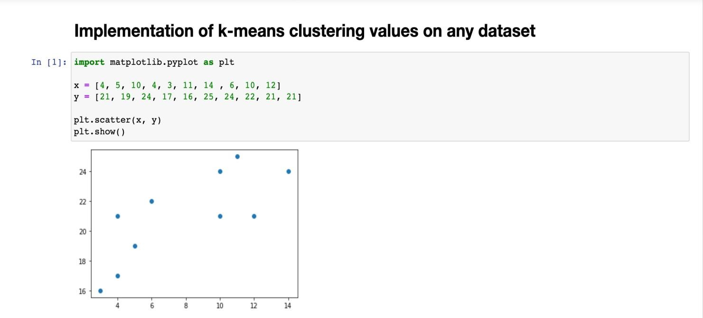

# COMPUTER SCIENCE & ENGINEERING



